Fundamentals of Programing

Lab Manual # 07

**Course Instructor:** Dr Jawad Khan

**Lab Instructor:** Muhammad Affan

## Student Name:

## Muhammad Abdullah Qureshi

## CMS ID:

## 456523

**DATE:**

**15th November 2023**

# TASK 1:

#include <iostream>

using namespace std;

int main(){

int i;

int array[10];

for(i=0; i<10; i++){

cout<<"Enter Value: ";

cin>>array[i];

}

for(i=0; i<10; i++){

cout<<"Index Number "<<i<<" - "<<array[i]<<endl;

}

return 0;

}

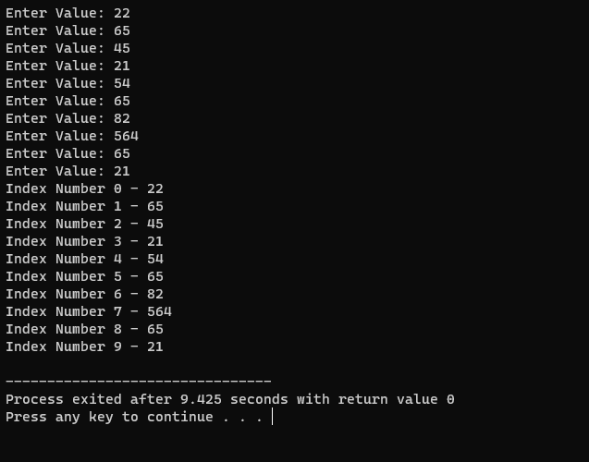

# TASK 2:

#include<iostream>

using namespace std;

int main(){

int sum=0, prod=1, i;

int array[5];

for(i=0; i<5; i++){

cout<<"Enter Values for Array: ";

cin>>array[i];

}

for(i=0; i<5; i++){

sum=sum+array[i];

prod=prod*array[i];

}

cout<<"Sum of All Elements of Array is: "<<sum<<endl;

cout<<"Product of All Elements of Array is: "<<prod<<endl;

return 0;

}

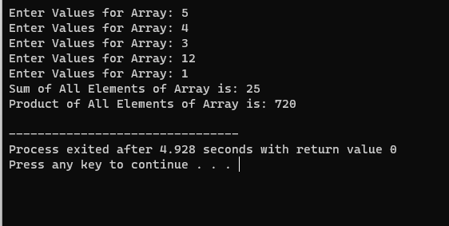

# TASK 3:

#include <iostream>

using namespace std;

int main()

{

int n, count, count2;

cout<<"Enter Number of Rows: ";

cin>>n;

int half = n/2;

char diamond[n];

for (count=0; count<n; count++)

{

diamond[count] = ' ' ;

}

for (count=0; count<=half; count++)

{

for (count2=0; count2<n; count2++)

{

diamond[half+count] = '*';

diamond[half-count] = '*';

cout<<diamond[count2];

}

cout<<endl;

}

for (count=0; count<n; count++)

{

diamond[count] = '*' ;

}

for (count=half; count>0; count--)

{

for (count2=0; count2<n; count2++)

{

diamond[half+count] = ' ';

diamond[half-count] = ' ';

cout<<diamond[count2];

}

cout<<endl;

}

return 0;

}

